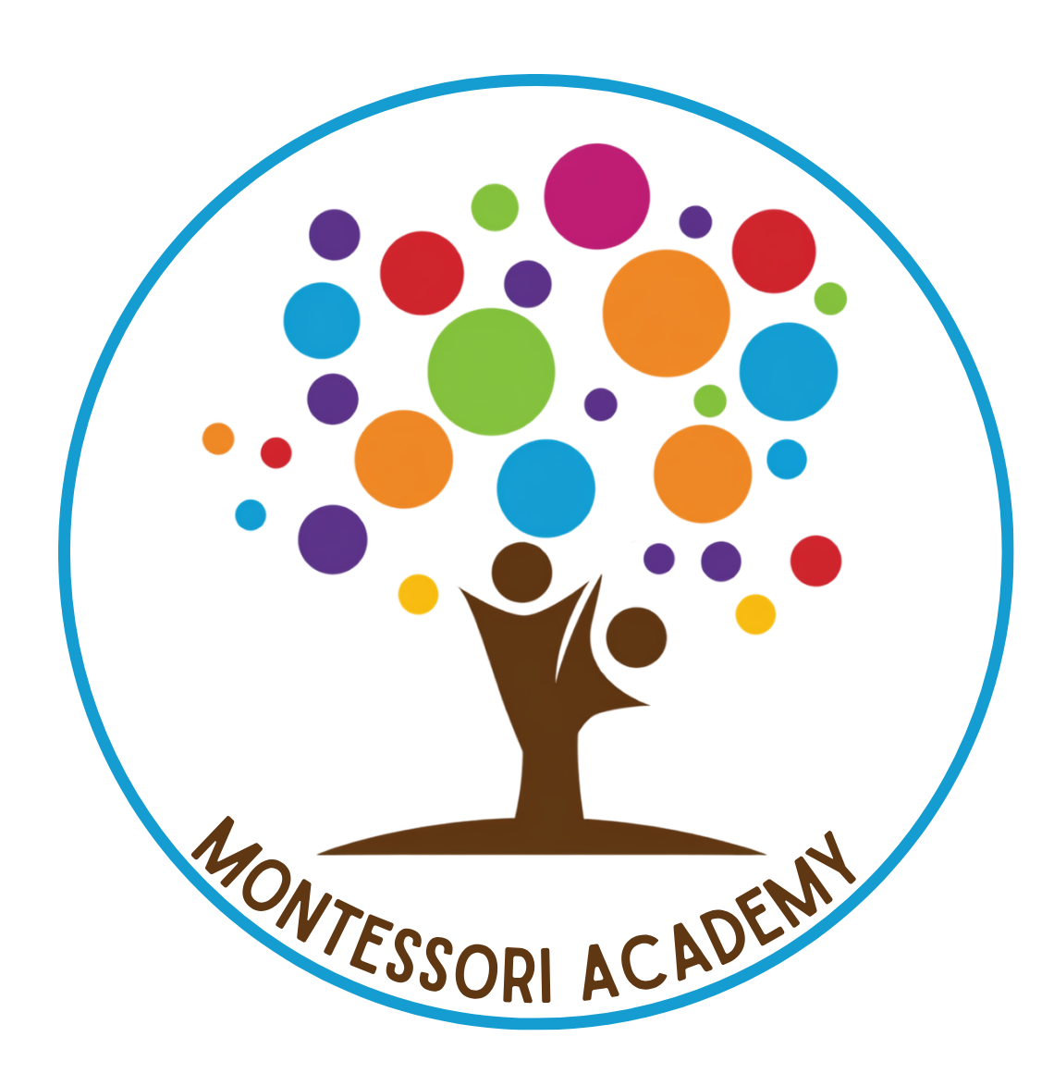

Montessori Academy (Home)
7712 234th ST SW., Edmonds, WA 98026

Monthly Tuition Fees 2026-2027

Hours: 8:30am – 4:00pm

5 days/wk | 4 days/wk | 3 days/wk | 2 days/wk | 1 day/wk
$1,595 | $1,495 | $1,395 | $1,025 | $695

Material fee (annually) $200

A registration fee of $200 is charged upon enrollment.

Prices are good from September 1st, 2026 - August 31st, 2027

